PROJECT REPORT

TOPIC :-

VAYUSETU
Advanced Airline Booking & Availability Management System

COURSE : PRGRAMMING IN C
( SOURSE CODE :- CSEG1041_5 )
Prepared by: Submitted to:
ADITYA GAUTAM MR. MOHSIN SAP ID :- 590026405 FURKH DAR


Problem STATEMENT
Airline booking systems involve multiple interconnected tasks such as flight listing, seat booking , PNR generation, cancellation validation , passenger activity tracking & fare comparison. Performing these manually leads to errors, inconsistencies & slow processing.

The objective of this project is to build a C-based airline booking system that simulates a real reservation environment without using databases, relying solely on structures, arrays, and functions.

Objectives:
- To display all available flights with route and seat data.
- To allow passengers to book seats and generate unique PNRs.
- To provide secure cancellation with validation checks.
- To simulate multi-site ticket fare comparison.
- To maintain a complete activity history log.
- To implement a clean, menu-driven user interface.

Software / Tools Used:
Operating System: Windows 10/11
Compiler: GCC (MinGW)
Editor: VS Code
Language: C Programming

Algorithm of Project:
1. START
2. Load initial flight data into structures.
3. Display main menu:
• View Flights
• Book Seat
• Cancel Seat
• Compare Prices
• View History
• Exit
4. Read user input.
5. Perform the selected operation.
6. Log every action in history[] array.
7. Return to menu until Exit is chosen.
8. STOP

Pseudocode of Project:
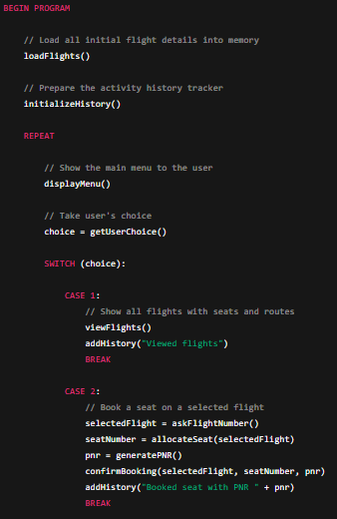
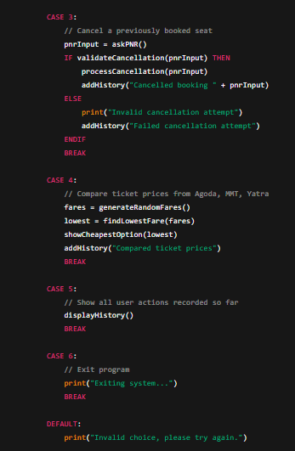
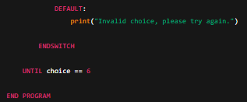

Sample Program Outputs:
- Viewing Flights:
Displays flight number, route, total seats, booked seats, and available seats.
2. Booking Seat:
Generates PNR, assigns next available seat, logs booking.
3. Cancellation:
Validates PNR + flight match, updates seat count.
4. Price Comparison:
Generates random fares for Agoda, MakeMyTrip, Yatra and shows cheapest.
5. History Log:
Shows all actions performed by the user.

Source Code :
- Airplane.c
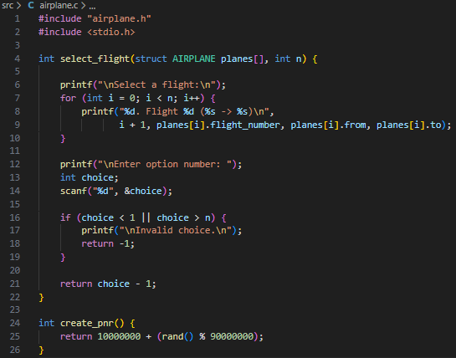
- Booking.c
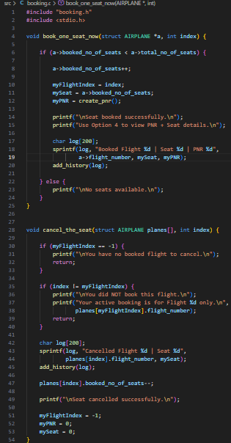
- Display.c
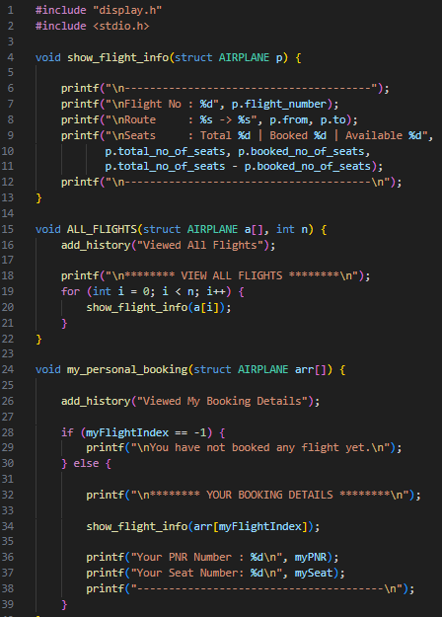
- History.c
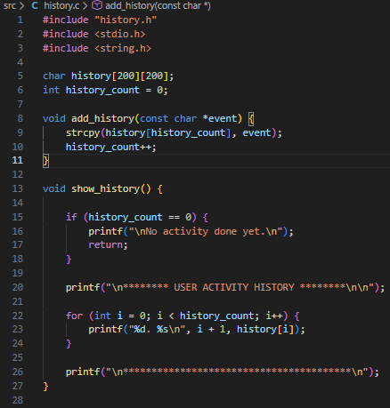
- Main.c
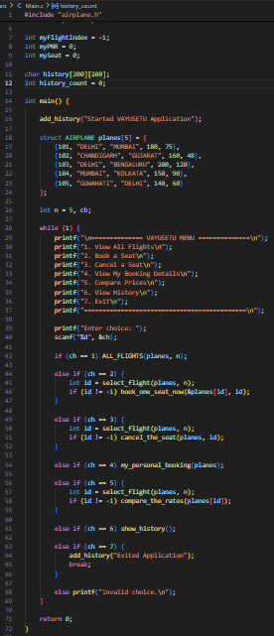
- Price compare.c
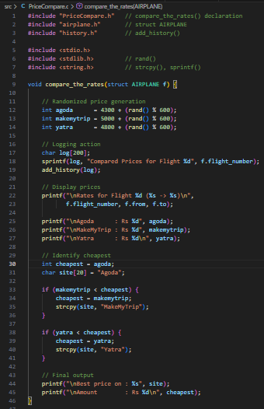

Conclusion:
The VAYUSETU Airline Booking System was successfully implemented using C. The project demonstrates structured programming, file-less data handling using arrays, decision-making & simulations like fare comparison & real-time history tracking. All objectives were achieved effectively.
Future Enhancements:
• Adding file-based permanent storage
• Multi-seat booking system
• Passenger authentication system
• Boarding pass generator (PDF/QR)
• GUI-based interface

